**LAB MANUAL 8**

# **LAB TASK**

## TASK 1

### CODE :

#include<iostream>

using namespace std;

int main(){

cout<<"enter the number of array";

int num,sum=0,avg=0;

cin>>num;

int values[num];

for(int i=0;i<num;i++){

cin>>values[i];

sum+=values[i];

}

avg=sum/num;

cout<<"the average of array is ="<<avg;

return 0;

}

### OUTPUT :

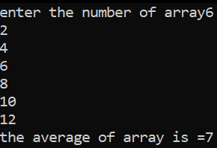

## TASK 2

### CODE :

#include<iostream>

using namespace std;

int main(){

cout<<"give elements of array:";

int arr[5];

int temp;

for(int i=0;i<5;i++){

cin>>arr[i];

}

for(int j=0;j<5;j++){

for(int k=0;k<4;k++){

if(arr[k]>arr[k+1]){

temp=arr[k+1];

arr[k+1]=arr[k];

arr[k]=temp;

}

}

}

cout<<"sorted array ia as"<<endl;

for(int m=0;m<5;m++){

cout<<arr[m];

}

return 0;

}

### OUTPUT :

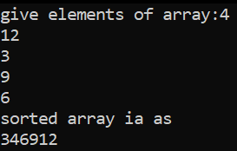

## TASK 3

### CODE :

#include<iostream>

using namespace std;

int main(){

cout<<"enter 5 numbers one by one ";

int values[5],num;

for(int i=0; i<5; i++){

cin>>values[i];

num=values[i];

for(int j=i; j<5; j++){

if(num > values[j]){

num=values[j];

values[j]=values[i];

values[i]=num;

}

}

cout<<values[i]<<" ";

}

return 0;

}

### OUTPUT :

